Research Findings Report

Executive Summary
This report analyzes anonymised customer transaction histories and behavioural patterns to identify key service pain points and usage trends. Our primary finding is the "Low Engagement Paradox" regarding the app's financial tools (Budgeting Tools, Savings Planner). While approximately 20% of transactions are associated with users who ignore these features, these non-users maintain the same—if not slightly higher—login frequencies and session durations as active feature users. Furthermore, this low engagement is heavily skewed toward older demographics (ages 46+).
The primary recommendation is to pivot from generalized engagement strategies to targeted UX/UI accessibility improvements and guided onboarding for older users, aiming to convert highly active app users into active feature users.

Introduction
The purpose of this report is to analyse customer transaction and behavioural data to uncover patterns, trends, and anomalies that indicate common customer pain points—specifically focusing on transaction declines, overdraft fees, and low engagement with budgeting tools.
The dataset comprises 1,500 anonymised customer records, capturing demographics (Age, Gender, Location), transaction details (Amount, Type, Category), and app usage metrics (Login Frequency, Session Duration, Feature Usage).

Methodology
Data collection and analysis were conducted using Python-based data science libraries for data manipulation and visual analysis.
The process included:
- Data Cleaning: Addressing 301 missing entries in the 'Feature Usage' column to isolate the "low engagement" user segment.
- Exploratory Data Analysis (EDA): Scanning transaction types and categories for error flags (declines/overdrafts).
- Demographic Segmentation: Grouping behavioural metrics by Age (into predefined cohorts), Gender, and Location to isolate behavioural drivers.

Findings
The data analysis revealed several distinct patterns regarding user behaviour and data structuring:
- Absence of Explicit Error Flags: The dataset did not contain specific categorisations for "Transaction Declines" or "Overdrafts," indicating a potential gap in data capturing.
- Consistent Core Engagement: Users who do not use features average 16.02 logins per month and 30.45-minute session durations, which slightly exceeds the overall averages (15.19 logins and 29.61 minutes).
- Age-Driven Feature Neglect: Low engagement with budgeting tools correlates strongly with user age. Only 15.9% of users aged 26-35 ignore the features, compared to 22.6% of users aged 46-55, and 23.5% of users aged 56+.
- Geographical Consistency: The rate of customers ignoring features remains consistent across all measured locations (London, Leeds, Birmingham, Manchester, Glasgow), hovering between 19.4% and 20.8%.
- Stable Spending Patterns: Average transaction amounts remain tightly clustered between £240 and £260 across nearly all demographics.

Analysis and Interpretation
The most significant insight from this data is the "Low Engagement Paradox." The assumption that low engagement with budgeting tools stems from a general lack of app usage is incorrect. Older users are logging into the app frequently and spending over half an hour per session, yet they are completely bypassing the financial planning features.
This indicates that the app's core functionality (checking balances, making transfers) is highly sticky, but the specific budgeting tools suffer from discoverability issues, a steep learning curve, or an intimidating User Interface (UI) for older demographics. The issue is not whether they use the app, but how they navigate it.

Recommendations
Based on the identified pain points, the following service improvements are recommended:
- Implement Targeted "Guided Tours": Introduce an interactive, easy-to-dismiss guided tutorial that highlights the Savings Planner and Budgeting Tools. Trigger this onboarding sequence specifically for users aged 45 and older.
- Develop an "Accessible" UI Mode: Consider designing a simplified dashboard view with larger typography and clearer, contrasting calls-to-action for the budgeting tools to accommodate older users who may find the current interface cluttered.
- Backend Data Enhancement: Update the transaction logging architecture to explicitly flag "Declines" and "Overdrafts" in the Transaction Status column. This will allow the product team to proactively trigger helpful interventions (e.g., prompting the user to use the Budgeting Tool immediately after an overdraft).
- In-App Nudges: Utilise the high session durations of the older demographic by introducing gentle, contextual nudges (e.g., "See how much you spent on Groceries this month") that deep-link directly into the budgeting features.

Conclusion
The application successfully retains user attention across all demographics, which is a strong foundation. However, to maximize the value of the platform, the business must address the age-related friction preventing the adoption of budgeting and savings features. By implementing targeted UI improvements and refining the data tracking for transaction errors, the service can significantly enhance user satisfaction and financial well-being for its older customer base.

Appendices

Appendix A: Charts and Visual Data
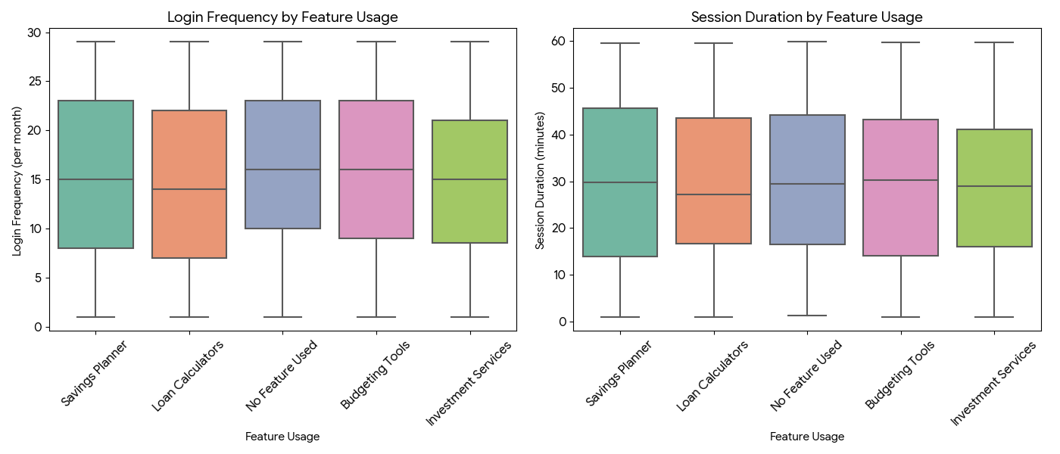
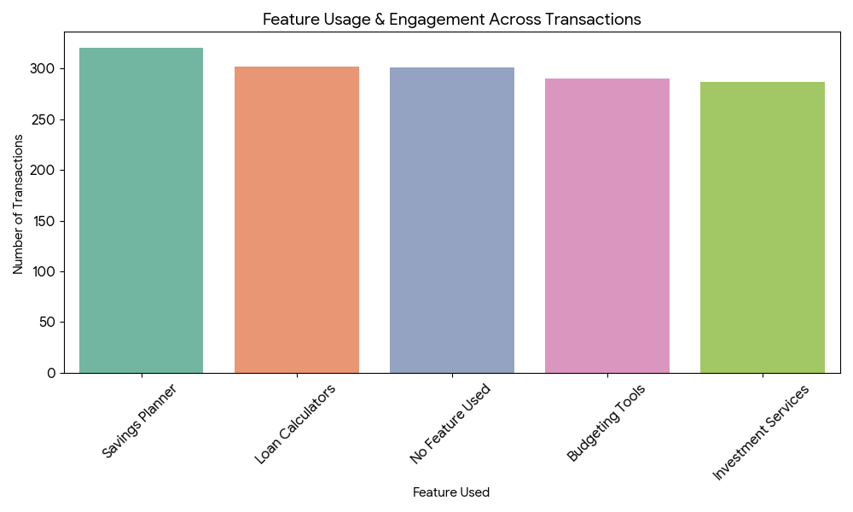

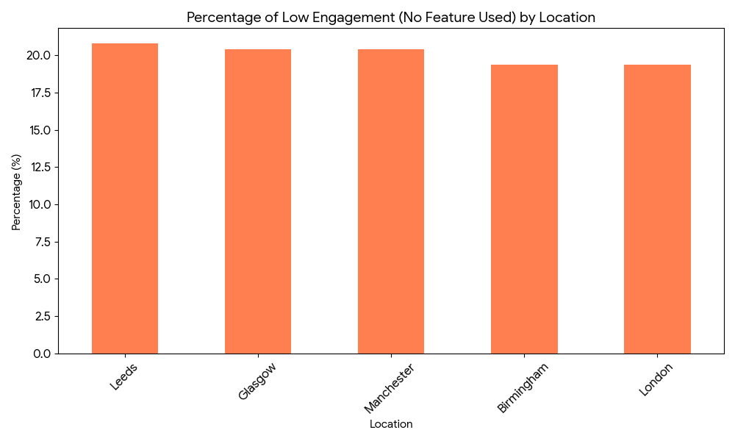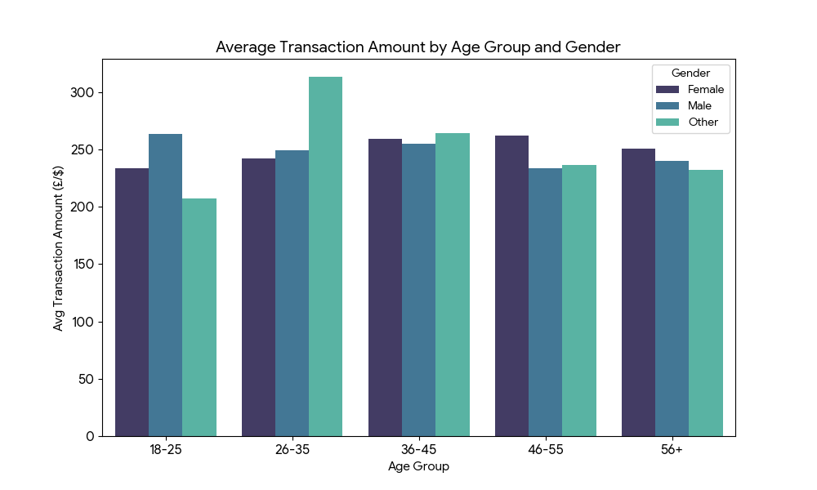

Appendix B : Customer_Insights_Summary
